
Arden University

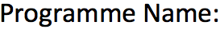
BSC(Hons) Computing

Introduction to Web Authoring

Website Project

STU1193426


Mohammad Amin Mohammadi Banadaki


Table of Contents

PART 1 3
Website specification 3
Website Name: Riesen wir zusamman … 3
1.Website goal: 3
2. key Audience: 3
3. Site Structure: 3
4. Functional specification (features & behaviour) 4
5. Website Comparison (3 examples — design, usability, accessibility) 5
6. SUMMARY 5
7 REFERENCE 5

PART 1

Website specification

Website Name: Riesen wir zusamman …
WEBSITE LINK: stu1193426.webhosting.arden.ac.uk

1.Website goal:

The primary goal of this website to inspire people to travel and explore world. Riesen wir zusamman by provid destination information, trip ideas and an easy enquiry/booking contact form. Secondary goals: build the brand (Tech Brains client), collect leads via the booking/contact form, and provide accessibility-aware content for international visitors.

2. key Audience:

- Adventure tourists , seeking trekking, camping and road trips. Mainly from Europe.
- Domestic Indians who want to travel in north part of India.
- International backpackers researching Himalayan routes.
Each and every visitor needs clear practical information, images, tips and simple contact/booking.

3. Site Structure:

- Provisional site structure (≥5 pages + form)
- Home — short intro , images (Manali snow/valleys), featured routes.
- Destinations — Manali, Spiti Valley: summary cards + “Read more”.
- Activities — trekking, road trips (Leh road), camping, local culture & permits.
- Book / Contact — enquiry form (name, email, phone, message).
- About & Safety — about the provider, travel safety & packing checklist, accessibility statement.
Plus: site footer with contact, small sitemap, and credits for imagery.
- Plus: mini logo on top right corner.

Functional specification (features & behaviour)

- Responsive layout: this website is very comfortably use by any person who has phone/tablet/desktop. Not important to only use in PC user can open from any browser or any device.

- Navigation: user can easily scroll and read content basically we can say that - visible focus styles.

- Image optimisation: compressed JPG/WEBP recommended, alt attributes for all images.

- Booking/Contact form: fields — name (text), email (email), phone (tel), message (textarea) and submit. So that people can share easily ask there question and also book for trip.

- Accessibility: semantic HTML5 (nav, header, main, footer), contrast checks, keyboard focus, and logical heading order. Basically using the features of HTML 5.

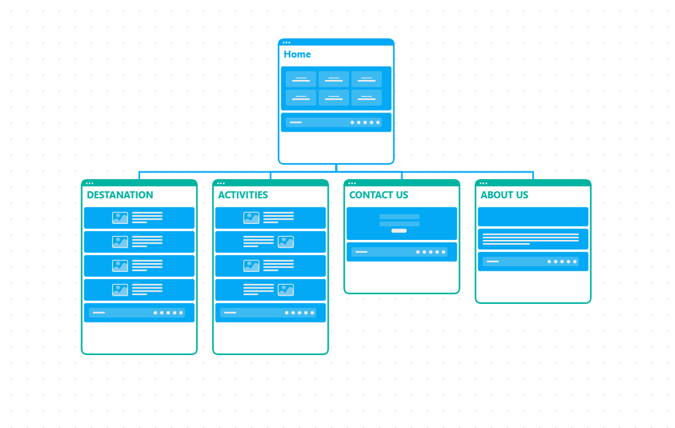

Website Comparison (3 examples — design, usability, accessibility)

- National Geographic Travel — strong hero imagery, clear typography, accessible contrast and descriptive alt-text; good content hierarchy. (https://www.nationalgeographic.com/travel)
- Airbnb demonstrates a highly modern and minimalistic interface. Large images, dynamic cards, and strong white-space usage make the site visually appealing. Navigation is extremely intuitive, with a clear search bar and predictable menu layout. The website uses responsive design effectively, performing consistently across desktop and mobile. However, the site relies heavily on JavaScript, which may affect loading times on slower networks. Airbnb (www.airbnb.com)
- Incredible India (official tourism) — local content, government info and simple contact links; sometimes dense text and less modern UI but high informational credibility. (https://www.incredibleindia.org)

SUMMARY

To sum up , Riesen wir zusamman … website help the traveler to travel throw Indian north side and get information + support throw contact us. And also this can be use by any browser and any device which user have.

REFERENCE

SATVIK THAKOR (2025) BACKGROUND , DESTANATION AND ACTIVITIES – Personal photograph taken with iPhone 15 Pro Max, 23 DEC 2024.
ROAMWITHHOM (2023) SPITI VALLEY. Pinterest. Available at: https://pin.it/4lHDDv897 (Accessed: 13 November 2025).
SATVIK THAKOR (2025) Sitemap for Website Project – Visual structure of all website pages including homepage, destination, activities, registration, gallery, and contact pages. Created by the SATVIK on 13 November.
W3Schools (2025) HTML Reference and Tutorials. Available at: https://www.w3schools.com/html.
Mozilla Developer Network (2025) CSS: Cascading Style Sheets Documentation. Available at: https://developer.mozilla.org/en-US/docs/Web/CSS .

